ASSIGNMENT STAGE 1
Shreya Jain
Central Queensland University

Step 2: Links to moodle profile and personal blog
- Moodle Profile: https://moodle.cqu.edu.au/user/profile.php?id=43284
- Personal Blog: http://helloshreyahome.wordpress.com
Step 3: My company: Li and Fung Limited
LF is a multinational supply chain management company based in Hong Kong, transacting in USD.
The financial performance overall is a loss in the prior financial year, upon the readings of the CEO and Chairman’s report in the financial statements for FY19, 2018 was a rough year for LF due to retail and sales sector which led to their total income/revenue deteriorating by 20%.
Total assets increased by 10% or $464k from 31 December 2017 to 31 December 2018. On the other hand, due to short term bank loans increasing by $250k, total liabilities increased from 2.3m in 2017 to 2.6m in 2018 (14% or $353k) as a result, net assets decreased significantly by 10.3m.
In my current surface level analysis of the company I note the following:
LF’s auditors are one of the top 10 Australian independent auditors, PriceWaterCoopers also known as PWC
Huge company with 17k employees worldwide
Top five sourcing countries are; India, China, Vietnam, Bangladesh and Indonesia
LF year on year execute a two pager, three year summary plan that entails key information about the services they provide, their values and vendor codes. Which would ideally provides security to the shareholders and investors
Lastly, towards the end of the financial statements, LF provide a ten year summary of the consolidated profit and loss accounts. This depicts the bigger picture in the financial analysis as we can compare year on year the financial position of the company. In comparison to other companies who tend to provide only a 3-5 consolidated summary.
Step 4: Company Financial statements
Please refer to the spreadsheet, you will need to download it separately
Step 5: Chapter 2 and 3 review:
Chapter 2;
I like the idea of the mindset to look at this like a game.

Step 6: Peer feedback

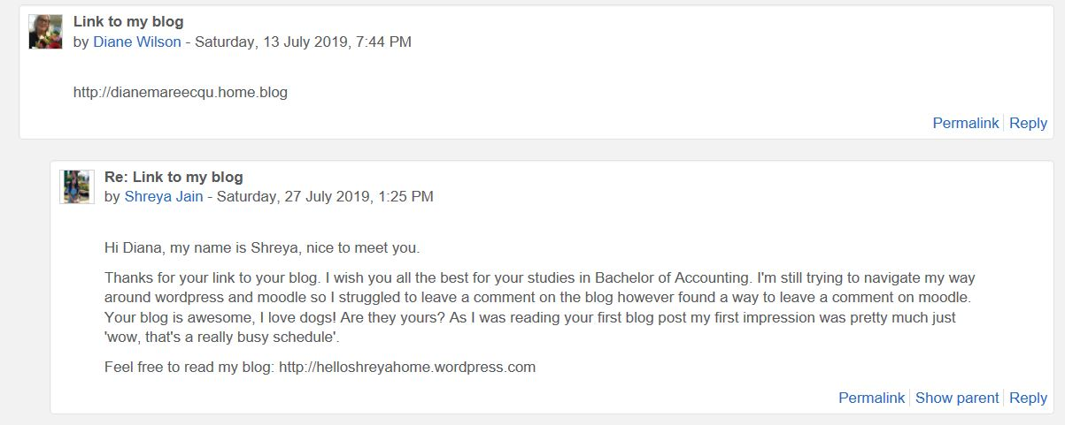
I have commenced a peer review for my fellow classmates:
Name and Student number | Grade
Leena Pun - 12119059
Binbin
Mahbub
Nguyen Thi Huong

Below is the template filled out in accordance with the students assignment 1.

Feedback From:
Feedback To: .

My Comments
Step 1
KCQs
Step 2
Introductory words in Description box
Photo and description
Link to your blog/Set up blog
Step 3
Background information on company
Comments/KCQs
Comments on other’s blogs
Step 4
Input company’s financial statements

Step 5
KCQs
Step 6
Individual feedback with others
Overall ASS#1
Feedback From:
Feedback To: .

My Comments
Step 1
KCQs
Step 2
Introductory words in Description box
Photo and description
Link to your blog/Set up blog
Step 3
Background information on company
Comments/KCQs
Comments on other’s blogs
Step 4
Input company’s financial statements

Step 5
KCQs
Step 6
Individual feedback with others
Overall ASS#1
Feedback From:
Feedback To: .

My Comments
Step 1
KCQs
Step 2
Introductory words in Description box
Photo and description
Link to your blog/Set up blog
Step 3
Background information on company
Comments/KCQs
Comments on other’s blogs
Step 4
Input company’s financial statements

Step 5
KCQs
Step 6
Individual feedback with others
Overall ASS#1
Feedback From:
Feedback To: .

My Comments
Step 1
KCQs
Step 2
Introductory words in Description box
Photo and description
Link to your blog/Set up blog
Step 3
Background information on company
Comments/KCQs
Comments on other’s blogs
Step 4
Input company’s financial statements

Step 5
KCQs
Step 6
Individual feedback with others
Overall ASS#1

